Brandon London

Final Project using R.

Stats

Case 1) This Case gives us a sample of birds who perished or survived base on their humerus length. They are asking us if the humerus lengths for the survivor’s matter compared to the ones who have perished, if there is even a difference. For the data set H0 states that the number of perished and survived groups are not different while Ha states that they are in fact different. To determine this, we must put the data into R.

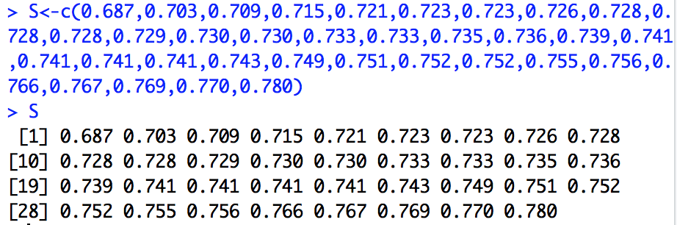

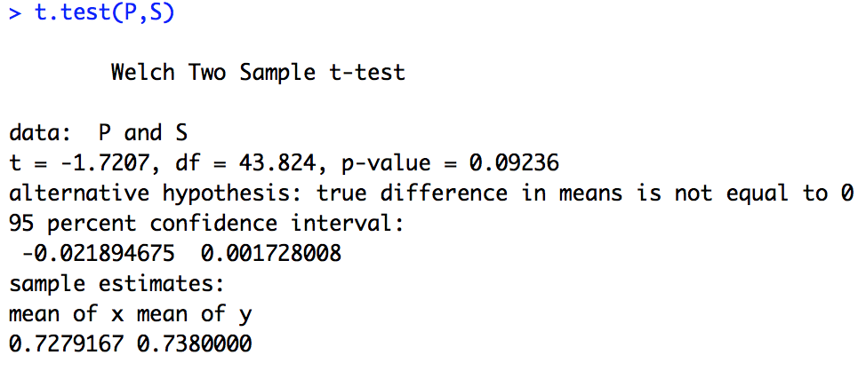

We can then use the data sets to make a box plot, Q-plot and the t-test (which I did above) to better see and compare the data sets.

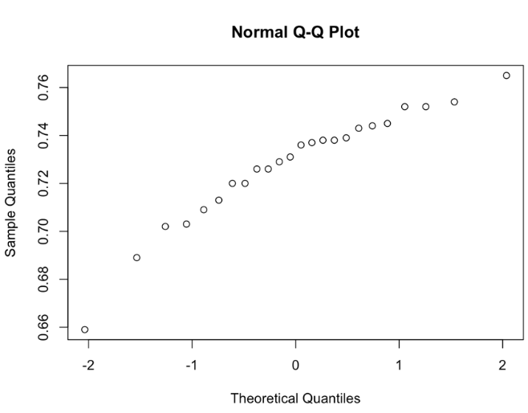

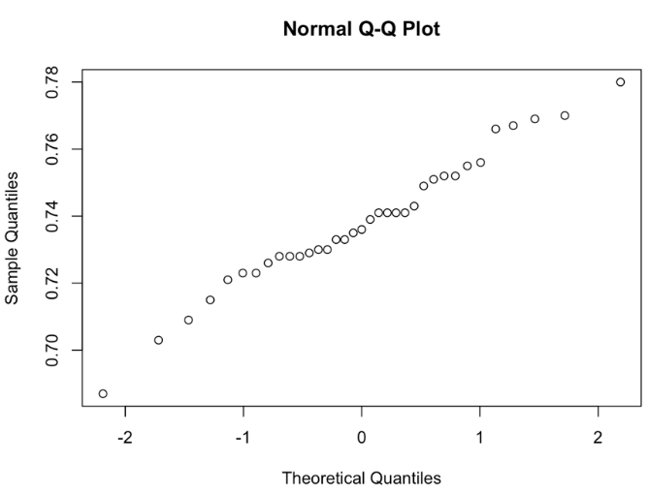

Summary of Statistical Findings: According to the calculations the average humerus length of survivors is 0.738, and the ones who perished are 0.7279. This data is suggestive but will be inconclusive. This is because the mean humerus length is between -0.0219 and 0.0017 inches greater in those that survived than those that have perished at a 95% confidence interval.

Scope of inference: This was an observational study, so the casual relationship cannot be inferred. It cannot be said that the longer humerus lengths of survivors is the reason that they survived. It should also be noted that they surviving birds collected came from a specific place and were easily gathered because they were stressed. It is risky to infer similarity of populations of stressed sparrows. The populations are hypothetical and there is no change model.

Case 2)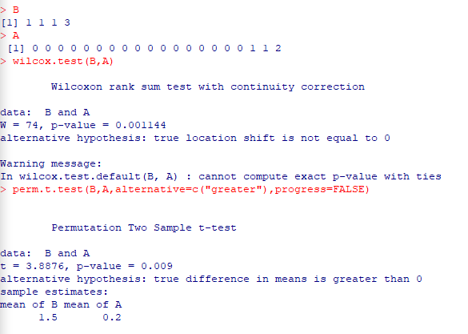

State your hypothesis here:

H0 = Launching at temperatures above 65 prevents O-ring incidents.

Ha = The risk of O-ring incidents during launches below 65 is equal.

Summary of Statistical Findings: There is significant evidence that the lower temperatures are associated with the number of O-ring incidents for this set of 24 launches. It is very unlikely that the difference between the two groups happened by chance with the one sided P value equaling 0.01 on the permutation test.

Scope of Inference: This data cannot be used to establish causality, also there is no broader population of which they are a sample from. The association between temperature and O-ring failure in these 24 launches is consistent with the theory that lower temperatures negatively affect O-ring functionality.

Case 3) First we must enter the data.

We can use the linear regression model to make sure that the distance is 0 at time interval 0.

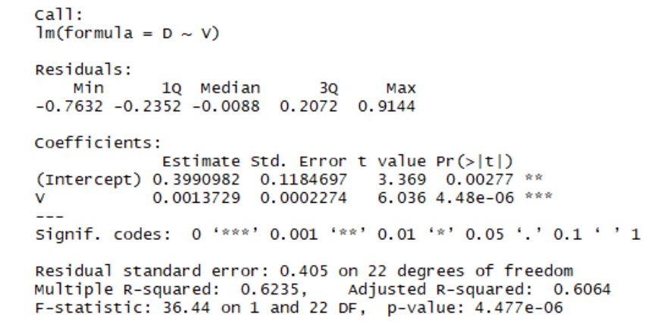

We are now going to make the linear model start at 0.

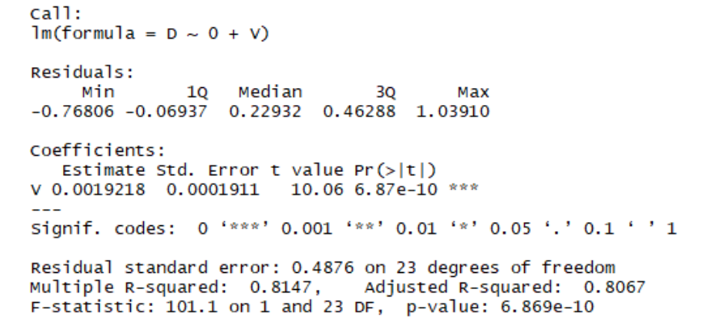

After fitting, plot the linear model to see if the linear regression is appropriate.

Summary of Statistical Findings: According to standard Physics distance and velocity are related and should make a very linear line on the graph, but velocity doesn’t equal 0 on the graph making a slight curve. The theory can also be defeated by using the two-sided p-value which equal 0.0028 for the test to make sure the intercept was 0, not only this but the Y interval wasn’t zero either. The Y intercept was 0.399 using the regression line equation. The age of universe was also 0.0019218 megaparsecs- seconds per kilometer.

Scope of Inference: This is not a random sample, so making inferences about other nebulae cannot be done. The analysis test that distance and velocity are directly correlated to make a straight line. This will get rid of your errors of measurement. With 95% confidence we can see that there are errors in the measurements. This can be given bias since these are not reflected in the P values. Note: The Big Bang Theory is still intact with estimates of the age of the universe ranging from eight to fifteen billion years, depending on what data is used.